1. A screenshot of a computer

   Description automatically generated
2. 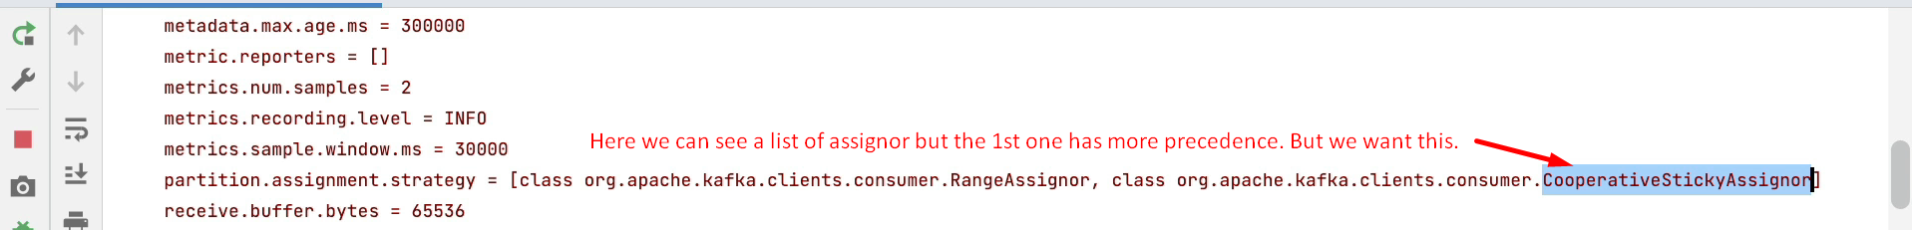Let’s change it.
3. A screenshot of a computer

   Description automatically generated
4. A close up of text

   Description automatically generated
5. A screenshot of a computer

   Description automatically generated
6. A white screen with red text

   Description automatically generated
7. A red line in a computer screen

   Description automatically generated